Grade | Course
8 | ELA
Unit Focus
Students will analyze the structure of two poems with a common theme. Students will write an essay that compares and contrasts how the structure and style of each poem contribute to the theme and meaning.
Standard(s)
8.RL.KID.2  8.RL.CS.5  8.RL.CS.4 | 8.W.2
Resource(s)
Texts:
- "I Wondered Lonely as A Cloud” (also called “Daffodil”) by William Wordsworth
- “World Below the Brine” by Walt Whitman
Task(s)
Day 1-Read “I Wondered Lonely as A Cloud” by William Wordsworth and “World Below the Brine” by Walk Whitman and complete figurative language analysis and vocabulary development.
Day 2-Analysis of lines in poems
Day 3-Analysis of Poem Structures
Day 4- Create Venn Diagram to compare/contrast both poems
Day 5-Writing Task

Expected Outcomes
Write an imforamtional essay that compares and contrasts how the style and structure of each poem contributes to the theme.

Additional Instructional Resources
I-Ready
All Rutherford County 6-8 grade students now have access to I-Ready ELA lessons. These lessons can be accessed via Clever. All available lessons have been assigned.

PBS Lessons
https://www.tn.gov/education/pbsteaching.html

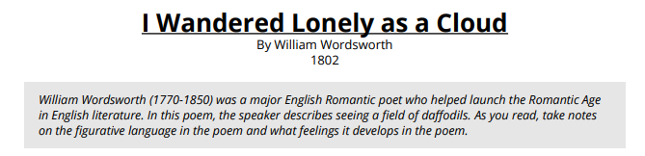
I wandered lonely as a cloud
That floats on high o'er vales and hills,
When all at once I saw a crowd,
A host, of golden daffodils;
Beside the lake, beneath the trees,
Fluttering and dancing in the breeze.

Continuous as the stars that shine
And twinkle on the milky way,
They stretched in never-ending line
Along the margin of a bay:
Ten thousand saw I at a glance,
Tossing their heads in sprightly dance.

The waves beside them danced; but they
Out-did the sparkling waves in glee:
A poet could not but be gay,
In such a jocund company:
I gazed—and gazed—but little thought
What wealth the show to me had brought:

For oft, when on my couch I lie
In vacant or in pensive mood,
They flash upon that inward eye
Which is the bliss of solitude;
And then my heart with pleasure fills,
And dances with the daffodils.

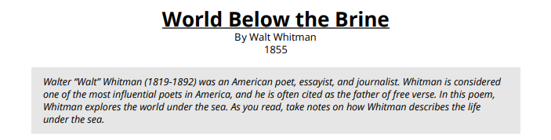
The world below the brine,
Forests at the bottom of the sea, the branches and leaves,
Sea-lettuce, vast lichens, strange flowers and seeds, the thick tangle, openings, and pink turf,
Different colors, pale gray and green, purple, white, and gold, the play of light through the water,
Dumb swimmers there among the rocks, coral, gluten, grass, rushes, and the aliment of the swimmers,
Sluggish existences grazing there suspended, or slowly crawling close to the bottom,
The sperm-whale at the surface blowing air and spray, or disporting with his flukes,
The leaden-eyed shark, the walrus, the turtle, the hairy sea-leopard, and the sting-ray,
Passions there, wars, pursuits, tribes, sight in those ocean-depths, breathing that thick-breathing air, as so many do,
The change thence to the sight here, and to the subtle air breathed by beings like us who walk this sphere,
The change onward from ours to that of beings who walk other spheres.

Day 1—Figurative Language and Vocabulary Development
Step 1: Figurative Language-After reading both poems, complete figurative language analysis for each poem.
“I Wandered Lonely as a Cloud” by William Wordsworth
1. Provide the line numbers where each figurative language occurs and then explain the meaning of each figurative language.
Simile:

Metaphor:

Personification:

“World Below the Brine” by Walt Whitman
2. Provide the line numbers where each figurative language occurs and then explain the meaning of each figurative language.
Imagery:

Simile:

Personification:

Step 2: Vocabulary Development—use the dictionary to define the meanings of each BOLDED word for both poems.
“I Wandered Lonely as a Cloud” by William Wordsworth
a) That floats on high o'er vales and hills______________________________________
b) Along the margin of the bay______________________________________________
c) Tossing their heads in sprightly dance_______________________________________
d) In such a jocund company________________________________________________
e) What wealth the show to me had brought____________________________________
f) For oft________________________________________________________________
g) In vacant or in pensive mood______________________________________________
h) Which is the bliss of solitude _____________________________________________

“World Below the Brine” by Walt Whitman
- The world below the brine _________________________________
- Sea-lettuce, vast lichens, strange flowers and seeds, the thick tangle, openings, and pink turf, __________________________________________
- Sluggish existences grazing there suspended, or slowly crawling close to the bottom, ______________________________________________
- The sperm-whale at the surface blowing air and spray, or disporting with his flukes, _________________________________________________
- The change thence to the sight here, and to the subtle air breathed by beings like us who walk this sphere, ____________________________________________________

Day 2—Comprehension
Step 1: Review your work from Day 1 and read both poems again.
Step 2: By using contextual clues (re-reading each line and trying to figure out what the words mean in the poem) explain what each one of the following lines mean. Concentrate on the underlined words for accuracy of analysis.
“I Wandered Lonely as a Cloud” by William Wordsworth
- I wandered lonely as a cloud
That floats on high o'er vales and hills,
____________________________________________________________

- When all at once I saw a crowd,
A host of golden daffodils;
____________________________________________________________

- Continuous as the stars that shine
And twinkle on the Milkyway,
____________________________________________________________

- They stretched in never-ending line
Along the margin of the bay:
___________________________________________________________

- The waves beside them danced; but they
Out-did the sparkling waves in glee:
___________________________________________________________
- I gazed - and gazed - but little thought
What wealth the show to me had brought:
____________________________________________________________

- For oft, when on my couch I lie
In vacant or in pensive mood,
____________________________________________________________

- They flash upon that inward eye
Which is the bliss of solitude;
____________________________________________________________

- And then my heart with pleasure fills,
And dances with the daffodils.
____________________________________________________________

“World Below the Brine” by Walt Whitman
- The world below the brine,
_______________________________________

- Forests at the bottom of the sea, the branches and leaves,
Sea-lettuce, vast lichens, strange flowers and seeds, the thick tangle, openings, and pink turf,

________________________________________________________________________________

- Different colors, pale gray and green, purple, white, and gold, the play of light through the water,
Dumb swimmers there among the rocks, coral, gluten, grass, rushes, and the aliment of the swimmers,

__________________________________________________________________________________

- Sluggish existences grazing there suspended, or slowly crawling close to the bottom,
The sperm-whale at the surface blowing air and spray, or disporting with his flukes,

_________________________________________________________________________________

- The leaden-eyed shark, the walrus, the turtle, the hairy sea-leopard, and the sting-ray,
Passions there, wars, pursuits, tribes, sight in those ocean-depths, breathing that thick-breathing air, as so many do,

______________________________________________________________________________________

- The change thence to the sight here, and to the subtle air breathed by beings like us who walk this sphere,

_________________________________________________________________________________

- The change onward from ours to that of beings who walk other spheres.

___________________________________________________________________________

Day 3—Structure Analysis

Step 1: Review your work from Day 1 and Day 2.
Step 2: Analyze the structure of each poem.

“I Wandered Lonely as a Cloud” by William Wordsworth
a) Stanzas 1 and 2 discuss the scene or setting of the poem. This is background
information that helps the reader make connections with the poet's mind. List the
specific details about the setting mentioned in stanza's 1 and 2.

Example: clouds floating over vales and hills

b) Stanza 3 explains how the poet felt, what he did, and how the scene affected him.
How did poet feel?________________________________________________________

What did poet do?________________________________________________________

How did the scene affect him?_______________________________________________

c) Stanza 4 delves into the reason the poet is writing about daffodils and lakes, vales
and hills. Analyze the connection the author is trying to make with you, the reader.
Especially look at the verbs he uses to create this feeling.

Where does he lie?
________________________________________________________________________
________________________________________________________________________

What flashes upon his eye?
________________________________________________________________________
________________________________________________________________________

What does he do, then, in his inward eye?
________________________________________________________________________
________________________________________________________________________

d) Have you ever been some place that you really liked? Describe the place.

“World Below the Brine” by Walt Whitman

- Walt Whitman describes the world below water. Research Oceanography to help you better understand the setting. Below, list the specific details that helps the reader make connections with the poet's mind.

For example: Forests at the bottom of the sea

- How can the description of the vast sea represent a person’s life above water?

- What are two theme statements Walt Whitman is trying to teach readers through this poem?

Day 4—Pre-Writing Task
Step 1: Review work from Days 1-3.
Step 2: Create a Venn Diagram to compare and contrast the structures of both poems.
- Below are some elements to consider for your diagram:
  - Theme
  - Figurative Language
  - Setting
  - Word Choice
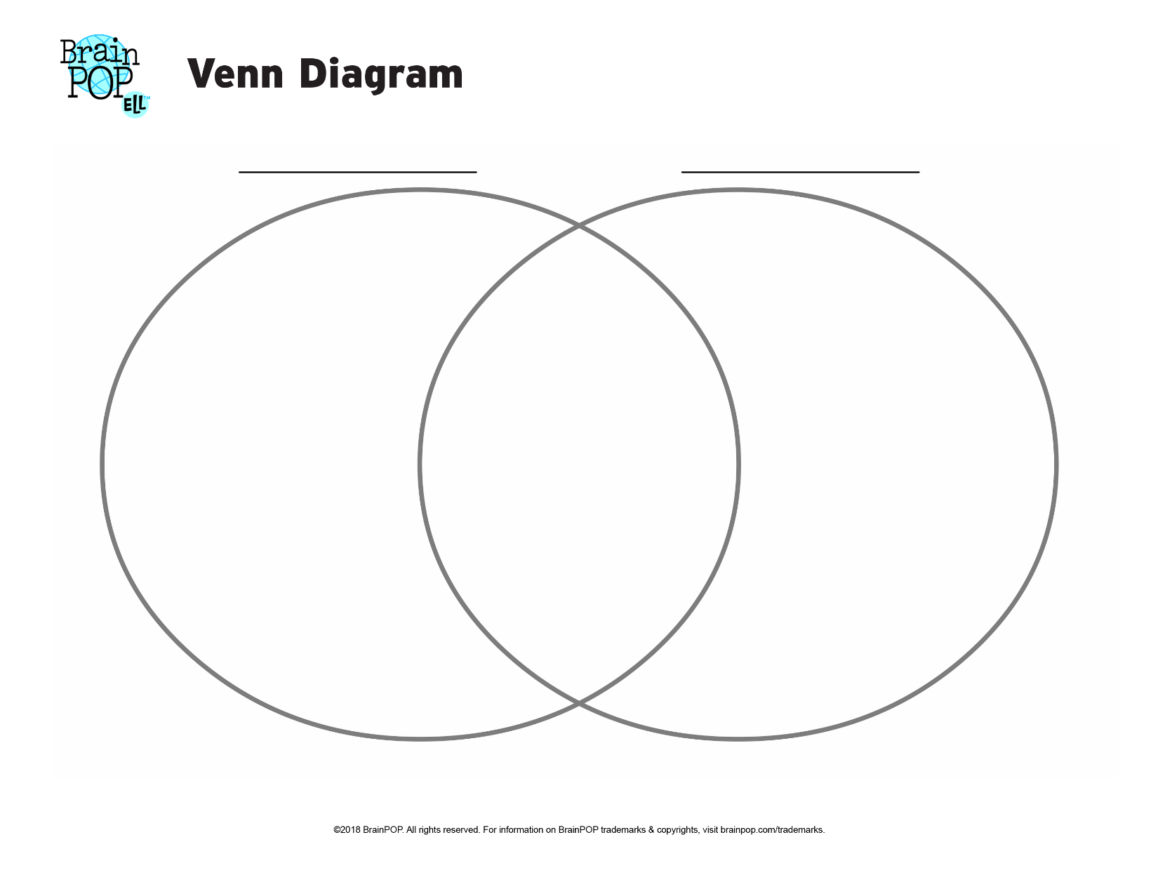

Day 5: Writing Task
Writing Task: Use the work you have completed from days 1-3 and the Venn Diagram from Day 4 to help you in writing your informational essay comparing and contrasting the style and structure that convey the theme of both poems read. Your essay should follow the structure and organization of an informational essay and the conventions of standard English

