Grade | Course
8 | ELA
Unit Focus
Students will read “How to Fact-Check the Internet” and analyze the format and structure of the text. Students will then choose from two culminating activities that will allow them to apply what they learned from the text.

Standard(s)
8.RI.KID.2  8.RI.KID.3  8.RI.CS.5 | 8.W.2 / 8.W.3 (depending on choice for culminating activity).
Resource(s)
Text(s): “How to Fact-Check the Internet”
https://choices.scholastic.com/issues/2019-20/120119/howt-to-fact-check-the-internet.html

Task(s)
Day 1 – Read the article: “How to Fact-Check the Internet” and complete summary and central idea tasks.
Day 2 – Venn Diagram: Compare/Contrast the text to a video clip
Day 3 – Determining the Credibility of Websites and providing evidence to support
Day 4 – Evaluating Sources
Day 5 – Writing Task

Expected Outcomes
Option 1: Write a letter to the leaders of social media sites explaining the dangers of misinformation and requesting that they flag posts they know to be untrue. Use information from the article to explain your arguments.

Option 2: Imagine you're designing a webpage for a favorite subject of yours. The webpage can be about your pet, or your favorite sport, or a new game you've made up. Make a sketch of what the page would look like, then circle or highlight all the elements that will convince users they can trust what they read on it.

Additional Instructional Resources
i-Ready

All Rutherford County 6-8 grade students now have access to I-Ready ELA lessons. These lessons can be accessed via Clever. All available lessons have been assigned.

PBS Lessons
https://www.tn.gov/education/pbsteaching.html

“How to Fact-Check the Internet” by Joey Bartolomeo
Secretly biased sites, viral hoaxes on Instagram, fake photos that look 100% real—no matter how digitally savvy you are, the web is full of false info. This guide will help you separate fact from fiction.
Junior Scholastic - DECEMBER 2019 / JANUARY 2020

iStockPhoto/Getty Images
This photo of a dolphin soaring in Hurricane Dorian’s winds was popular on social media back in September. It looks crazy, but is it real? Nope! According to Snopes.com (which fact-checks tons of viral content), it’s actually a photo from Hurricane Frances in 2004, with a dolphin inserted into the image.

Tip 1: Understand the Shock-and-Share Cycle
1. You see something that’s OMG, like a headline claiming that climate activist Greta Thunberg is an actress. (ICYMI, she’s not.)
2. This triggers an immediate emotional response, instead of one that makes you go, “Wait, is this true?” So you quickly share it with your followers.
3. When your followers see the post, they’re surprised as well, and they share it too. (It goes on and on and on.)
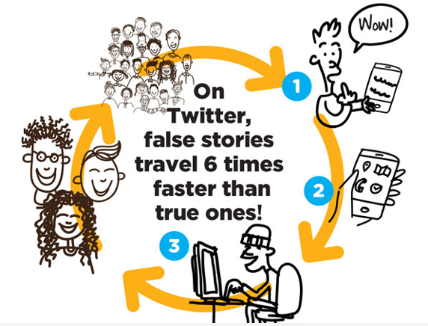
Shutterstock.com
Stop the insanity! Experts say the key is to exercise what’s called click restraint: Before you repost, retweet, or re-whatever, wait 30 seconds and ask yourself, “Do I know this is real?” If the answer is no, don’t hit “share” until you’ve done some research (more on that in a bit!).

Tip 2: Become a Decoding Master
This tweet was supposedly sent from Snapchat. Here’s how to find out if it’s real:
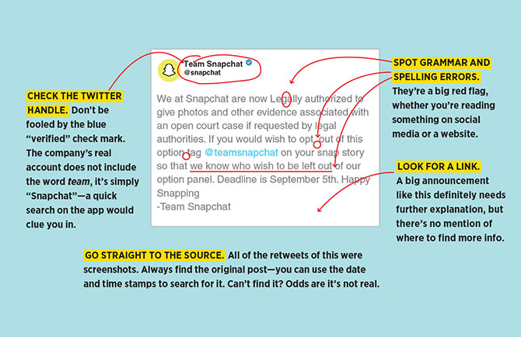

Tip 3: Ask Yourself: Am I Making These Common Mistakes?
atiger/Shutterstock.com

82% of middle schoolers didn’t know the difference between a real news story and sponsored content.

- Reading Only a Headline: One study found that 59 percent of links shared on social media don’t get clicked. Don’t just believe the grabby headline—take time to read and understand the story.
- Thinking That First Means Best: Just because a site ends up in the top search spot doesn’t mean it’s the most reliable source.
- Getting Wowed by Cool Visuals: Research shows that teens find data-filled charts and well-designed sites persuasive, but don’t judge something on looks alone. Anyone can make a fancy-looking website or infographic. Always check where the data came from.
- Falling For a Trick URL: Fake news sites copy the names of real ones to get clicks, so always look at the URLs and beware of an extra domain after .com (abcnews.com.co) or a twist on a real URL (nytimesofficial.com instead of nytimes.com).
- Not Realizing a Post is an Ad: Brands pay influencers and websites to be featured in stories, videos, and posts. If you see the words “sponsored content,” #ad, “paid partnership,” or “presented by,” it’s not neutral. Someone is trying to sell you something.
"That Time I Shared a Bogus Blog Post"
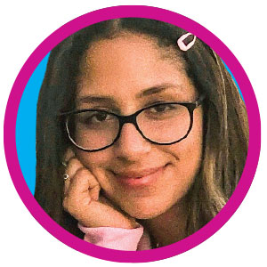
courtesy of family
“Once, I impulsively reposted what I thought was a Khalid quote I saw on VSCO. Instantly, my DMs were flooded with friends telling me it was actually from a fan page. I felt so embarrassed! Social media is such a big part of my life, and I want people to take what I post seriously. Now I always make sure to double-check that the source is legit.”

Tip 4: Influencer < Expert
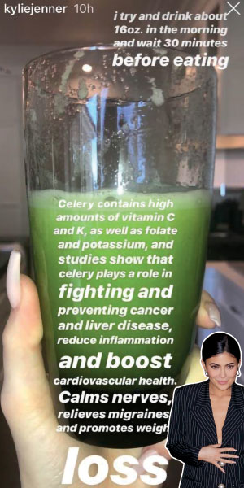
@kyliejenner/Instagram (green smoothie); Jackson Lee/GC Images/Getty Images (Kylie Jenner)

Dr. Kylie?! Nope!

Remember when Kylie Jenner claimed that drinking celery juice could cure literally everything? Even if you don’t, it’s the perfect example of what we’ll call celebrity nonexpert syndrome—when stars spew advice they’re not qualified to give (and we believe them!). So before you consider any information as fact, ask yourself, “What makes this person an expert in ________?” If the answer is “I don’t know” or “Nothing,” then don’t let them be your only source.
How to Fact-Check Like a Pro
Professional fact checkers use a technique called “lateral reading,” which involves opening up several tabs at a time and searching for more details about a topic and evaluating the sources providing the information. The goal is to find out . . .
- Who is behind the info and can you trust them?
- What's the evidence?
- What do other sources say?
Want to learn more? John Green (the famous author!) hosts videos on navigating digital info. Find them at the CrashCourse YouTube channel.

Tip 5: Learn These Two Words: Confirmation Bias.
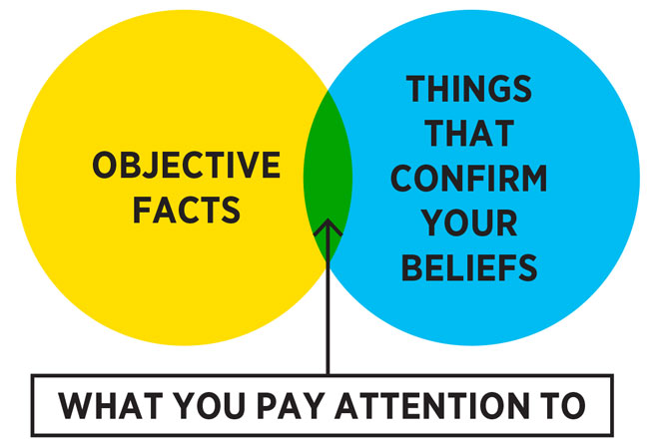
Sometimes the real reason you fall for certain types of stories is . . . YOU! Confirmation bias leads people to accept views that match their own. So if you’re passionate about the environment, you may believe and/or share anything you see about the effects of global warming because you assume it’s true. (Beware: There’s misleading info out there on all sides.) On the other hand, if you see a story that isn’t in line with your thinking, you may just assume it’s not true.

Day 1 – Summary and Central Idea
- Read: “How to Fact-Check the Internet” by Joey Bartolomeo
- One Word Summary - Write one word that summarizes the text. (This word may be taken directly from the text). Next, write a 2-3 sentence paragraph that explains or defends how the word summarizes the text.
One word that summarizes “How to Fact-Check the Internet” is ______________________.
______________________________________________________________________________________________________________________________________________________________________________________________________________________________________________________________________________________________________________________________________________________________________________________________________
- Determine the central idea of the text and provide three pieces of textual evidence to support your central idea. Write in complete sentences.
Textual Evidence #1

Central Idea:
Textual Evidence #2

Textual Evidence #3

Day 2 – Venn Diagram: Compare/Contrast the text to a video clip

- Reread the text: How to Fact-Check the Internet by Joey Bartolomeo and look over your work from yesterday.

- Watch the video clip: How to Fact-Check Online Sources | Authentication 101 | Reality Check
  - https://www.youtube.com/watch?v=Kim9ujIU874

- Create a Venn Diagram to compare and contrast the text to the video clip.
  - Below are some elements to consider for your diagram:
    - Central Ideas
    - Word Choice
    - Graphics

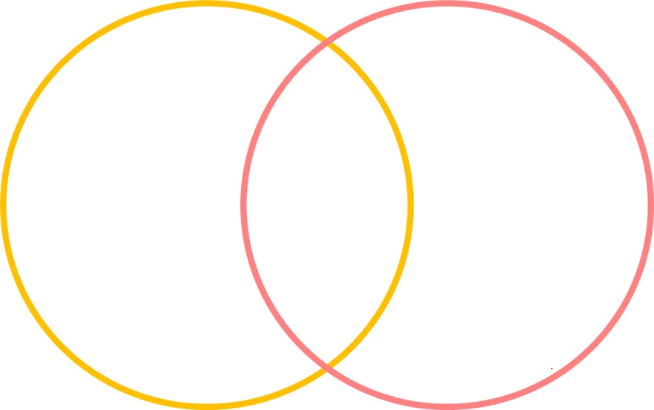

Day 3 – Determining the Credibility of Websites and providing evidence to support

- Open each website on the list below and briefly review it. Then answer the questions.

www.noaa.gov
eps.berkeley.edu
Wikipedia.org/wiki/Marine_Life_Protection_Act
www.oceanfdn.org
www.mbgnet.net
www.theguardian.com/environment/georgemonbiot/ 2016/feb/15/save-uk-seas-from-governments-who-make-a-mockery-of-marine-conservation

The websites you just explored had different domain extensions (the 3 letters at the end of their URLs).

- What do you think each domain extension is short for?

.gov
.edu
.org
.com
.net

2. Is one type of domain extension more credible than another? Use evidence from the websites to explain your response.

________________________________________________________________________________________________________________________________________________________________________________________________________________________________________________________________________________________________________________________________________________________________________________________________________________________________________________________________________________________________________________________________________________________________________________________________________________________________________________

Reference (Help with question 1):
Credibility of domain extensions.
- .edu: academic institution (college, university)
- .gov: official U.S. government agency
- .com: commercial/company
- .org: organization (often nonprofit organizations, but can be commercial)
- .net: network (often Internet service providers, but can be commercial)
URLs (or Universal Resource Locators) can have a variety of different extensions, or endings, and some are more credible than others. In general, any URL ending in .edu or .gov is likely to be credible. URLs ending in .com, .org, or .net are ones that need validating by corroborating information. Of course, you should corroborate information from the .edu and .gov sites as well.

- This question has two parts.

Part 1: Imagine that you are writing a report about air pollution. Select the two most credible sources:
- Sydney Walters, author of three best sellers on endangered animals

- Rose Page, author of three articles on climate change and air quality

- Kirk Bellows, professor of English literature and author of twelve books on Shakespeare

- Elizabeth Edmund, professor and scientist at MIT and author of Take a Deep Breath, a non-fiction book about the history of air pollution

Part 2: Why did you choose these two authors? What makes them credible?

______________________________________________________________________________________________________________________________________________________________________________________________________________________________________________________________________________________________________________________________________________________________________________________________________

Day 4: Evaluating Sources
Select one of the websites below (hold ctrl and click on the link). View and evaluate the site, then answer the questions.
  - Burmese Mountain Dog
  - Boilerplate: Mechanical Marvel of the Nineteenth Century
  - Feline Reactions to Bearded Men
  - The Pacific Northwest Tree Octopus
- Who is the author?

- Is the author an expert on the subject?

- Is it a well-known and respected organization or website?

- Is the information on the website mainly facts or opinions?

- Does the information on the site contain prejudice, sharing only the facts or opinions that support the author’s opinion of the subject?

- Does the website make any claims? Are the claims supported with evidence?

- What evidence did you find convincing about the author's argument? What evidence did you find questionable?

- Did the links work? Did they take you to credible websites?

- Why might so many students and adults be fooled by a website like this?

Circle Yes or No
A 2017 U.S. Fish and Wildlife Service official report on the effects of pollution on marine life
- Would a source like this be credible? YES NO

A pet owner’s blog about her sick fish
- Would a blog like this be a credible source for medical information about fish?
YES NO

A current article about illegal waste disposal, published by a middle school newspaper
- Would a source like this be credible? YES NO

An article in a recent issue of The New York Times about oil spills and bird life
- Would a source like this be credible? YES NO

Day 5: Writing Task

- Choose one of the writings tasks below to complete.

Option 1: Write a letter to the leaders of social media sites explaining the dangers of misinformation and requesting that they flag posts they know to be untrue. Use information from the article and anything you have learned this week in your ELA tasks to explain your arguments.

Option 2: Imagine you're designing a webpage for a favorite subject of yours. The webpage can be about your pet, or your favorite sport, or a new game you've made up. Make a sketch of what the page would look like, then circle or highlight all the elements that will convince users they can trust what they read on it.

